|  |  |  |  |
| --- | --- | --- | --- |
| 1 | | 67,657 | |
| **NUMERO DE FRONTERAS** | | **ENERGIA AGREGADA** | |
|  | | | |
| 305,425,588 | 140 | | 13,226,625 |
| INGRESO 2021 | DÍAS CERTIFICADOS 2021 | | ENERGIA RESPALDADA 2021 |

**HISTORICO REINTEGRO DDV**

|  |  |
| --- | --- |
|  | **2021** |
| **ENE** | 38.57 |
| **FEB** | 59.5 |
| **MAR** | 29.57 |
| **ABR** | 16.64 |
| **MAY** | 60.49 |
| **JUN** | - |
| **JUL** | - |
| **AGO** | 26.97 |
| **SEP** | 43.33 |
| **OCT** | 30.36 |
| **NOV** | - |
| **DIC** | - |

**Los valores de la tabla están en millones de COP**

**REINTEGRO MECANISMO DDV OCTUBRE 2021**

|  |  |  |  |  |  |
| --- | --- | --- | --- | --- | --- |
| FECHA | TIPO DIA | CANTIDADES RESPALDO | PRECIO PONDERADO USD | TRM | PNETO |
| 2021-10-06 | Miércoles | 93,572 | 5.98 | 3,784.44 | 1,897,391 |
| 2021-10-07 | Jueves | 93,569 | 5.98 | 3,784.44 | 1,897,330 |
| 2021-10-08 | Viernes | 93,569 | 5.98 | 3,784.44 | 1,897,330 |
| 2021-10-09 | Sábado | 93,572 | 5.98 | 3,784.44 | 1,897,391 |
| 2021-10-10 | Domingo - Festivo | 93,572 | 5.98 | 3,784.44 | 1,897,391 |
| 2021-10-11 | Lunes | 93,572 | 5.98 | 3,784.44 | 1,897,391 |
| 2021-10-19 | Martes | 93,572 | 5.98 | 3,784.44 | 1,897,391 |
| 2021-10-20 | Miércoles | 93,572 | 5.98 | 3,784.44 | 1,897,391 |
| 2021-10-21 | Jueves | 93,569 | 5.98 | 3,784.44 | 1,897,330 |
| 2021-10-22 | Viernes | 93,569 | 5.98 | 3,784.44 | 1,897,330 |
| 2021-10-23 | Sábado | 93,569 | 5.98 | 3,784.44 | 1,897,330 |
| 2021-10-24 | Domingo - Festivo | 93,572 | 5.98 | 3,784.44 | 1,897,391 |
| 2021-10-25 | Lunes | 93,572 | 5.98 | 3,784.44 | 1,897,391 |
| 2021-10-26 | Martes | 93,569 | 5.98 | 3,784.44 | 1,897,330 |
| 2021-10-27 | Miércoles | 93,572 | 5.98 | 3,784.44 | 1,897,391 |
| 2021-10-28 | Jueves | 93,572 | 5.98 | 3,784.44 | 1,897,391 |

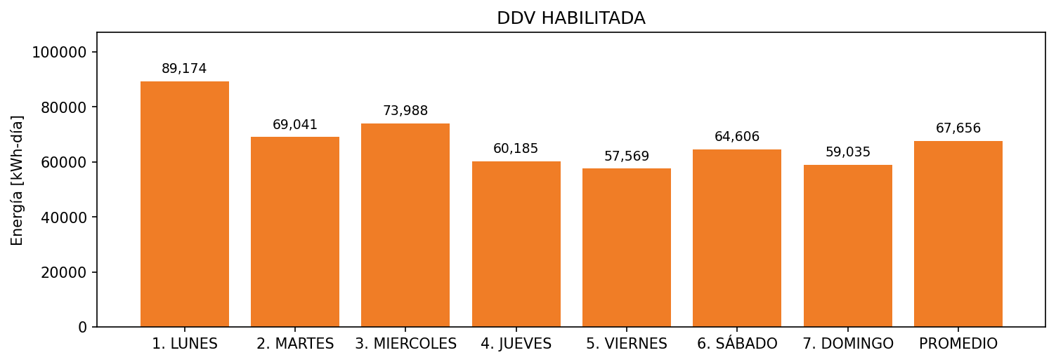

|  |  |  |  |  |  |  |  |  |  |
| --- | --- | --- | --- | --- | --- | --- | --- | --- | --- |
| **FRONTERA** | **COD SIC** | **FRT DDV** | **TIPO DDV** | **PROMEDIO** | **PRÓXIMA ACTUALIZACIÓN** | **MARGEN DE ERROR** | **ÚLTIMA PRUEBA DDV** | **DÍAS PARTICIPACIÓN** | **FECHA REFERENCIA PRÓXIMA PRUEBA DDV** |
| PRAXAIR YUMBO | Frt11003 | Frt30838 | LBC | 67,656 | 2022-03-10 | 59,87 | 2021-08-08 | 48.0 | 2022-01-17 |